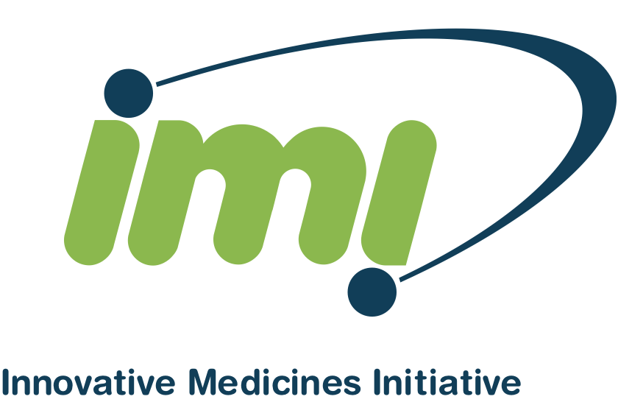 | EXPRESSION OF INTEREST:  Scientific Section  Proposal Acronym:  Proposal Full Name:

Contents

1. List of Abbreviations 2
2. Scientific case 2
2.1 Concept and Objectives 2
2.2 Potential impact and risks 2
2.3 References List 2
3. Project Plan 2
3.1 Outline of the structure and timelines of the project 2
3.2 Work-packages List 3
3.3 Main Deliverables list for all work-packages for the 3
entire project 3
3.4 Indicative budget plan 3
4. Partnership case 3
4.1 Individual Participants: Short profile of the key staff members undertaking the work 3
4.2 Consortium as a whole 4
5. Ethics 5
5.1 Ethical Issues Table 5
Declaration (submitted by the Applicant Consortium coordinator on behalf of the Applicant Consortium) 6

1. List of Abbreviations

2. Scientific case
Please refer to the ‘Guidelines on preparation of an IMI Full Project proposal’ for details on the cot of this section.

2.1 Concept and Objectives

2.2 Potential impact and risks

2.3 References List

3. Project Plan

3.1 Outline of the structure and timelines of the project

3.2 Work-packages List
Work-package No. | Work-package title | Type of activity
WP1
WP2
…

3.3 Main Deliverables list for all work-packages for the

entire project
Del. No. | Deliverable name | WP No. | Nature | Indicative Delivery date

3.4 Indicative budget plan

4. Partnership case

4.1 Individual Participants: Short profile of the key staff members undertaking the work

Name | Sex | Job title and role in  the proposed project | Mini-CV including 3 most relevant publications/patents

When relevant :
Individual participant clinical site: Evidence of the ability to fulfill all the clinical site requirements as outlined in the Call topic text.
Institution/clinical centre name: <name>

4.2 Consortium as a whole

5. Ethics

5.1 Ethical Issues Table
Ethical Issues Table: | YES | PAGE
Research on Humans:
Does the proposed research involve children?
Does the proposed research involve patients?
Does the proposed research involve patients or persons not able to give consent?
Does the proposed research involve adult healthy volunteers?
Does the proposed research involve Human Genetic Material?
Does the proposed research involve Human biological samples?
Does the proposed research involve Human data collection?
I CONFIRM THAT NONE OF THE ABOVE ISSUES APPLY TO MY PROPOSAL
Research on Human embryo/foetus:
Does the proposed research involve Human embryos?
Does the proposed research involve Human Foetal Tissue/Cells?
Does the proposed research involve Embryonic Stem Cells? (hESCs)
Does the proposed research on hECSs involve cells in culture?
Does the proposed research involve the derivation of cells from Embryos?
I CONFIRM THAT NONE OF THE ABOVE ISSUES APPLY TO MY PROPOSAL
Privacy:
Does the proposed research involve processing of genetic information or personal data (e.g. health, sexual lifestyle, ethnicity, political opinion, religious or philosophical conviction)?
Does the proposed research involve tracking the location or observation of people?
I CONFIRM THAT NONE OF THE ABOVE ISSUES APPLY TO MY PROPOSAL
Research on Animals:
Does the proposed research involve research on animals?
Are those animals transgenic small laboratory animals?
Are those animals transgenic non-rodents?
Are those animals transgenic farm animals?
Are those animals cloned farm animals?
Are those animals non-human primates?
I CONFIRM THAT NONE OF THE ABOVE ISSUES APPLY TO MY PROPOSAL
Research Involving Developing Countries:
Does the proposed research involve the use of local resources (genetic, animal, plant etc.)
Is the proposed research of benefit to local communities (e.g. capacity building, access to healthcare, education, etc.)?
I CONFIRM THAT NONE OF THE ABOVE ISSUES APPLY TO MY PROPOSAL
Dual Use:
Research having direct military application
Research having the potential for terrorist abuse
I CONFIRM THAT NONE OF THE ABOVE ISSUES APPLY TO MY PROPOSAL

Declaration (submitted by the Applicant Consortium coordinator on behalf of the Applicant Consortium)
By participating in this Expression of Interest and submitting it to the IMI Joint Undertaking, each participant declares that (i) he/she has read and understood the IMI IP policy incorporated in the Grant Agreement, and (ii) to the best of his/her knowledge, as of the submission date, there is no agreement, or contract to which he/she is a party or to which he/she is bound, which might encumber his/her ability to comply with the IMI IP policy and the corresponding Grant Agreement provisions.

